**Full Stack Development with MERN**

**Database Design and Development Report**

| Date | 11th july, 2024 |
| --- | --- |
| Team ID | SWTID1720019605 |
| Project Name | Grocery - web app |
| Maximum Marks |  |

**Project Title**: Farmzi

**Date**: 11/07/24

**Prepared by**: SWTID1720019605

**Objective**

The objective of this report is to outline the database design and implementation details for the [Your Project Title] project, including schema design and database management system (DBMS) integration.

**Technologies Used**

* **Database Management System (DBMS):** MongoDB
* **Object-Document Mapper (ODM):** Mongoose

**Design the Database Schema**

The database schema is designed to accommodate the following entities and relationships:

**1. Users**

- Attributes: name , email , password

**2. Posts**

- Attributes: [list attributes like _id, title, content, author (references User), createdAt, updatedAt]

**3. Comments**

- Attributes: [list attributes like _id, text, post (references Post), author (references User), createdAt, updatedAt]

**Implement the Database using MongoDB**

The MongoDB database is implemented with the following collections and structures:

Database Name: [your_database_name]

1. Collection: users

- Schema:

```

{

_id: ObjectId,

name: String,

email: String,

password: String,

createdAt: Date,

updatedAt: Date

}

```

2. Collection: posts

- Schema:

```

{

_id: ObjectId,

title: String,

content: String,

author: ObjectId (references users),

createdAt: Date,

updatedAt: Date

}

```

3. Collection: comments

- Schema:

```

{

_id: ObjectId,

text: String,

post: ObjectId (references posts),

author: ObjectId (references users),

createdAt: Date,

updatedAt: Date

}

```

**Integration with Backend**

Database connection: Give Screenshot of Database connection done using Mongoose

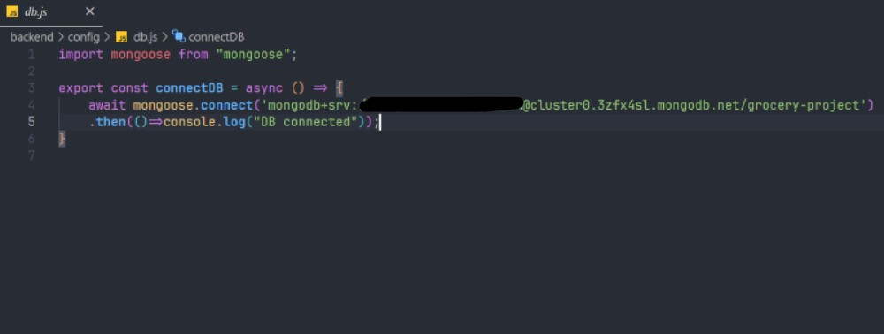

The backend APIs interact with MongoDB using Mongoose ODM Key interactions include:

* + User crud operations : login register
  + food crud operations: addfood, listfood, removefood
  + order operations: placeorder, verifyorder, userorders, listorders, updatestatus
  + cart operations: addtocart, removefromcart, getcart